**Design Thinking Project Workbook**

**Don't find customers for your product but find products for your customers**

**1. Team**

**Team Name:**

**FITNESS TRACKER**

**Team Members:**

1. L.Abijeet - 2320030193
2. G.Nikhil sai- 2320030195
3. D Krishna Kethan Reddy - 2320030198

**2. Problem/Opportunity Domain**

**Domain of Interest: The domain of interest for this innovative idea is fitness and wellness technology, specifically in the area of personalized health and fitness tracking. This industry is growing rapidly with increasing interest in maintaining a healthy lifestyle. The application focuses on providing users with tailored workout plans, activity monitoring, and wellness advice. It integrates fitness routines, nutritional guidance, stress management techniques, and progress tracking, catering to diverse health goals such as weight loss, muscle gain, and overall well-being. The idea leverages technology to offer a personalized and accessible approach to health improvement.**

**Description of the Domain: The fitness and wellness technology domain focuses on using digital tools like apps and wearable devices (e.g., smartwatches) to help people stay healthy by offering personalized workout plans, tracking their activity, and providing health advice.**

**The main challenges include keeping users engaged, protecting personal data, and making sure the tools work for people with different fitness levels. There’s also a lot of competition in this field.**

**However, there are many opportunities as more people are looking for ways to stay healthy, especially with remote solutions and personalized fitness plans. New technology like AI-based coaching and advanced tracking tools can make a big impact in improving people’s health.**

**Why did you choose this domain?: I chose the fitness and wellness technology domain because of its immense market potential and growing demand as people increasingly focus on health, fitness, and overall well-being. Personally, I’m passionate about helping individuals live healthier lives, and I see an opportunity to solve key challenges like providing personalized fitness plans and wellness advice that are accessible to everyone. This domain also allows for innovation through technology, like AI-driven solutions, which can make staying fit easier and more engaging for users, especially in a world moving towards digital health solutions.**

**3. Problem/Opportunity Statement**

**Problem Statement: The problem is that many individuals struggle to maintain a consistent fitness routine and achieve their health goals due to a lack of personalized guidance, motivation, and accessibility to expert advice. Generic workout plans and health advice often fail to meet the unique needs of different users, leading to frustration, loss of motivation, and ineffective results. This issue is particularly important because it affects people's physical and mental well-being, contributing to rising health issues like obesity, stress, and inactivity. Solving this problem requires a solution that delivers tailored, accessible, and engaging fitness and wellness support for diverse users.**

**Problem Description: The issue is that most fitness and wellness solutions offer one-size-fits-all plans, which fail to cater to the unique needs, fitness levels, and goals of individuals. This lack of personalization often leads to users feeling overwhelmed, unmotivated, or unable to achieve desired results. Additionally, there’s a gap in integrating fitness, nutrition, and mental well-being into a cohesive and accessible platform. This challenge is further amplified by busy lifestyles, making it difficult for people to consistently follow a structured wellness routine. A personalized, flexible solution is needed to address these gaps and support long-term health improvement.**

**Context (When does the problem occur): The problem arises when individuals attempt to start or maintain a fitness routine without proper guidance or tailored plans that suit their specific needs, goals, and schedules. It commonly occurs in the following situations:**

* **Beginners feel overwhelmed by not knowing where to start, leading to inconsistent workouts or giving up.**
* **Busy individuals struggle to find time for regular exercise or healthy meal planning, resulting in a lack of consistency.**
* **People with unique health goals (such as weight loss, muscle gain, or stress reduction) often find that generic plans don’t address their specific needs.**
* **Users lose motivation over time when they don’t see immediate results or lack ongoing support, making it hard to stay committed.**

**These conditions highlight the need for a solution that provides personalized, flexible, and motivating guidance.**

**Alternatives (What does the customer do to fix the problem): To address the problem of inconsistent fitness routines and lack of personalized guidance, customers typically turn to several existing solutions, though each has its limitations:**

1. **Generic workout apps or online videos: Users often rely on free or low-cost apps and YouTube videos for workouts, but these lack personalization and can lead to ineffective results or injury if done incorrectly.**
2. **Gym memberships or personal trainers: Some people invest in gym memberships or hire personal trainers for customized guidance, but these options can be costly and time-consuming, making them inaccessible to many.**
3. **Wearable fitness trackers: Devices like smartwatches help track steps, heart rate, and sleep patterns, but they don't provide tailored workout or nutrition plans to achieve specific goals.**
4. **DIY plans: Many individuals attempt to create their own fitness and meal plans by piecing together information from different sources. However, this can be confusing, overwhelming, and lead to inconsistent results.**

**While these solutions help to some extent, they often fail to offer the personalized, flexible, and holistic support that users need to stay motivated and achieve their health goals effectively.**

**Customers (Who has the problem most often): The primary group affected by this problem includes individuals who are trying to improve their fitness and overall health but lack personalized guidance and support. This group can be broken down into several key segments:**

1. **Beginners in fitness: People new to exercise often feel overwhelmed by where to start and need clear, structured guidance.**
2. **Busy professionals: Individuals with demanding schedules who struggle to find time for consistent workouts and healthy eating habits.**
3. **People with specific health goals: Those aiming to lose weight, gain muscle, or reduce stress often find that generic plans don’t address their unique needs.**
4. **Individuals struggling with motivation: Many people start a fitness routine but lose motivation when they don’t see immediate results or face difficulties sticking to a plan.**
5. **Older adults or those with medical conditions: These individuals may need specialized, low-impact workout routines and wellness support tailored to their health limitations.**

**Each of these groups regularly faces challenges in maintaining a consistent and effective fitness routine, making them the most affected by this problem.**

**Emotional Impact (How does the customer feel): Customers facing challenges in sticking to a fitness routine often feel a mix of emotions and frustrations:**

1. **Overwhelmed: Beginners may feel confused about where to start with all the information out there.**
2. **Frustrated: They can get frustrated when generic plans don’t work, feeling like their efforts are wasted.**
3. **Disappointed: Those who set health goals but don’t see progress often feel let down and question their dedication.**
4. **Stressed: Busy people may feel stressed trying to balance work, family, and health, making it hard to focus on fitness.**
5. **Lonely: Many feel isolated in their fitness journey without the support or guidance they need.**
6. **Insecure: Frequent setbacks can lower their confidence, making them doubt their ability to reach their goals.**

**These feelings can make it tough for individuals to stay motivated and committed to living a healthier life.**

**Quantifiable Impact (What is the measurable impact): The quantifiable impact of challenges in maintaining a fitness routine can be observed in several measurable areas:**

1. **Financial Losses: Individuals may spend money on gym memberships, personal trainers, or fitness classes that they do not utilize fully, leading to wasted expenses averaging $300 to $500 annually for inactive memberships.**
2. **Time Wasted: Many people invest considerable time in searching for effective workout plans or trying various routines without seeing results, potentially wasting 5 to 10 hours per week.**
3. **Health Costs: Poor fitness and health can lead to increased medical expenses due to obesity-related conditions or stress-related illnesses, which can average around $1,500 to $3,000 per year per individual.**
4. **Lost Productivity: The stress and frustration from failed fitness efforts can lead to decreased productivity at work, impacting overall job performance and potentially costing employers $1,200 per employee annually due to absenteeism and lower output.**
5. **Decreased Motivation: The emotional toll of not achieving fitness goals can result in a longer-term disengagement from physical activity, potentially leading to lifelong habits of inactivity, which are challenging to quantify but can contribute to chronic health issues.**

**These measurable impacts highlight the need for effective solutions to support individuals in their fitness journeys.**

**4o mini**

**Alternative Shortcomings (What are the disadvantages of the alternatives): The current alternatives that customers use to address their fitness and wellness challenges have several shortcomings:**

1. **Generic Workout Plans: Many apps and online videos provide one-size-fits-all routines that do not cater to individual needs, fitness levels, or personal goals, often resulting in ineffective workouts.**
2. **Costly Personal Training: While hiring personal trainers offers personalized guidance, it can be expensive and often requires a significant time commitment, making it inaccessible for many.**
3. **Limited Features of Wearable Devices: Although fitness trackers can monitor activity and health metrics, they typically lack comprehensive workout plans or nutrition guidance, leaving users without a holistic approach to their fitness.**
4. **DIY Plans: Individuals trying to create their own fitness and nutrition plans may struggle with misinformation or lack of structure, leading to confusion and inconsistent results.**
5. **Lack of Motivation: Many existing solutions do not provide ongoing support or accountability, which can lead to decreased motivation and engagement over time.**
6. **Time-Consuming Research: Customers often spend considerable time searching for effective routines and advice, which can be overwhelming and discourage them from taking action.**

**These limitations highlight the need for a more integrated and personalized solution that addresses users’ unique fitness and wellness requirements effectively.**

**Any Video or Images to showcase the problem: The evidence in the form of video or image).**

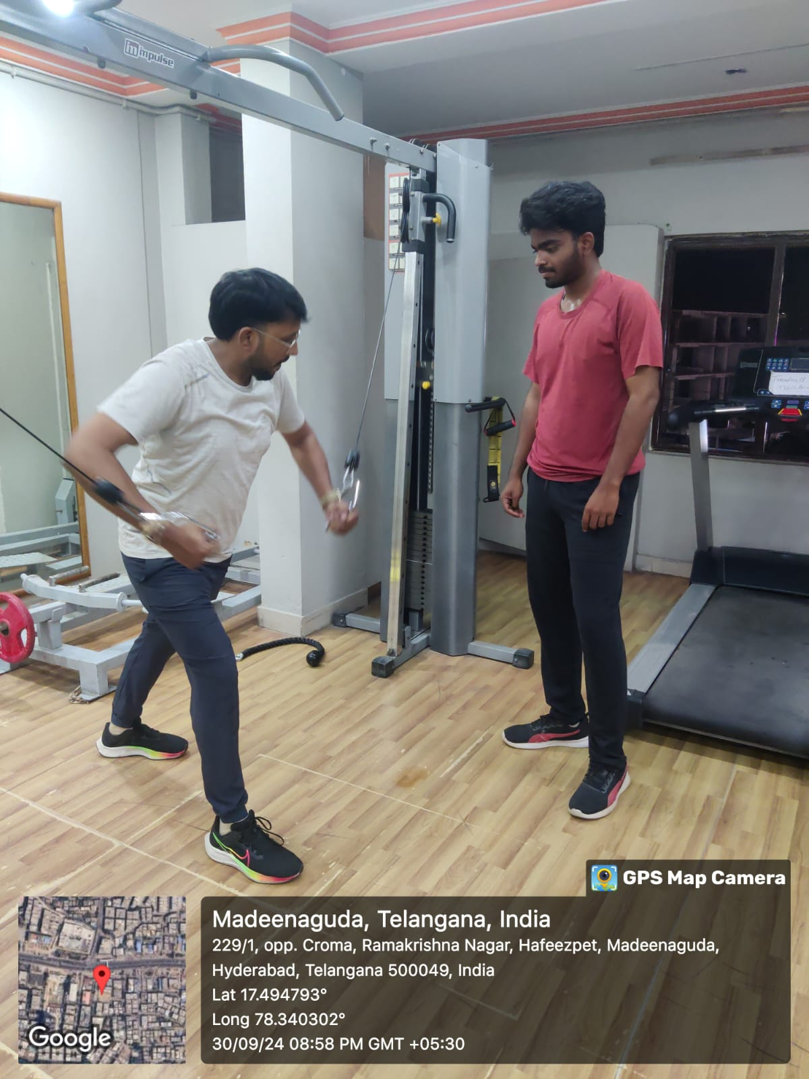

**3. Addressing SDGs**

**Relevant Sustainable Development Goals (SDGs): The problem of inconsistent fitness routines and lack of personalized health support impacts several of the Sustainable Development Goals (SDGs):**

1. **SDG 3: Good Health and Well-Being - This goal aims to ensure healthy lives and promote well-being for all. Improving fitness and wellness directly contributes to better physical and mental health.**
2. **SDG 4: Quality Education - By providing personalized fitness education and resources, people can learn about health and wellness, promoting lifelong learning in these areas.**
3. **SDG 5: Gender Equality - Tailored fitness solutions can empower all individuals, regardless of gender, to take charge of their health and well-being.**
4. **SDG 10: Reduced Inequalities - Making personalized fitness and wellness resources accessible can help reduce health disparities among different socio-economic groups.**
5. **SDG 11: Sustainable Cities and Communities - Promoting physical fitness can lead to healthier communities and reduce healthcare costs, contributing to more sustainable urban living.**

**These SDGs emphasize the importance of health and well-being, education, and equality, making the fitness and wellness domain relevant to global sustainable development efforts.**

**How does your problem/opportunity address these SDGs?: olving the problem of inconsistent fitness routines and lack of personalized health support can help achieve several Sustainable Development Goals (SDGs) in the following ways:**

1. **SDG 3: Good Health and Well-Being: By providing personalized fitness plans, people can improve their physical and mental health, leading to healthier communities and lower healthcare costs.**
2. **SDG 4: Quality Education: Offering resources and education about fitness and nutrition helps people learn how to stay healthy, promoting lifelong knowledge about well-being.**
3. **SDG 5: Gender Equality: Making fitness resources accessible to everyone empowers all genders to take charge of their health, helping to eliminate barriers that prevent certain groups from getting the support they need.**
4. **SDG 10: Reduced Inequalities: By providing affordable and accessible fitness solutions, we can help reduce health disparities among different socio-economic groups, ensuring everyone has the chance to improve their health.**
5. **SDG 11: Sustainable Cities and Communities: Encouraging active lifestyles through personalized fitness can lead to healthier urban populations, resulting in better quality of life and lower healthcare costs in communities.**

**Overall, this solution not only addresses individual health issues but also supports broader societal goals for a healthier, more equal, and sustainable future.**

**4o mini**

**4. Stakeholders**

Answer these below questions to understand the stakeholder related to your project

1. **Who are the key stakeholders involved in or affected by this project?**

The key stakeholders in the fitness and wellness tracking chatbot project include **users** seeking personalized health advice, **fitness trainers** who provide expertise, **healthcare providers** who may refer patients, and **technology developers** responsible for building the chatbot. Additionally, **investors**, **fitness brands**, **regulatory bodies**, and **community organizations** play important roles in supporting and promoting the project.

1. **What roles do the stakeholders play in the success of the innovation?**

Stakeholders contribute to the fitness and wellness tracking chatbot's success in various ways:

1. **Users**: Provide feedback to enhance features and improve user experience.
2. **Fitness Trainers**: Offer expertise to ensure reliable and effective workout plans.
3. **Healthcare Providers**: Refer patients, helping to expand the user base.
4. **Technology Developers**: Build and maintain the chatbot, ensuring functionality and security.
5. **Investors**: Provide funding for growth and innovation.
6. **Fitness Brands**: Create promotional partnerships that attract users.
7. **Regulatory Bodies**: Ensure compliance with health regulations to maintain user trust.
8. **Community Organizations**: Promote the chatbot, increasing awareness and usage
9. **What are the main interests and concerns of each stakeholder?**
10. **Users**:
    1. **Interests**: Personalized fitness plans and effective health advice.
    2. **Concerns**: Data privacy and the accuracy of information.
11. **Fitness Trainers**:
    1. **Interests**: Collaborating to provide expert guidance and gaining new clients.
    2. **Concerns**: How their expertise is represented and competition from the chatbot.
12. **Healthcare Providers**:
    1. **Interests**: Tools that enhance patient outcomes and preventive care.
    2. **Concerns**: Reliability of the chatbot’s advice.
13. **Technology Developers**:
    1. **Interests**: Building a functional and innovative chatbot.
    2. **Concerns**: Technical challenges and ongoing maintenance.
14. **Investors**:
    1. **Interests**: Return on investment and market viability.
    2. **Concerns**: Financial risks and competition.
15. **Fitness Brands**:
    1. **Interests**: Brand visibility and promotional partnerships.
    2. **Concerns**: Alignment with the chatbot's mission.
16. **Regulatory Bodies**:
    1. **Interests**: Ensuring compliance with health regulations.
    2. **Concerns**: Potential misinformation.
17. **Community Organizations**:
    1. **Interests**: Promoting health and wellness in the community.
    2. **Concerns**: Effectiveness of the chatbot in supporting their mission.
18. **How much influence does each stakeholder have on the outcome of the project?**

Here's a summary of the influence each stakeholder has on the outcome of the fitness and wellness tracking chatbot project:

1. **Users**: High influence due to their feedback driving adoption and satisfaction.
2. **Fitness Trainers**: Moderate to high influence, enhancing credibility and user trust.
3. **Healthcare Providers**: Moderate influence through referrals, depending on alignment with patient needs.
4. **Technology Developers**: High influence as they determine functionality and user experience.
5. **Investors**: High influence through financial support and strategic direction.
6. **Fitness Brands**: Moderate influence through partnerships, depending on collaboration success.
7. **Regulatory Bodies**: High influence due to the necessity of compliance with health regulations.
8. **Community Organizations**: Moderate influence, primarily through promotion and engagement.
9. **What is the level of engagement or support expected from each stakeholder?**

Here's the expected level of engagement or support from each stakeholder in the fitness and wellness tracking chatbot project:

1. **Users**: High engagement is expected through regular feedback and usage of the chatbot.
2. **Fitness Trainers**: Moderate support is anticipated through collaboration and content contribution.
3. **Healthcare Providers**: Moderate engagement is expected, mainly through referrals and endorsements.
4. **Technology Developers**: High support is needed for continuous development and maintenance of the chatbot.
5. **Investors**: High engagement is expected, particularly in funding and strategic guidance.
6. **Fitness Brands**: Moderate support is anticipated through promotional partnerships and collaborations.
7. **Regulatory Bodies**: Low engagement, but high compliance support is essential for adherence to regulations.
8. **Community Organizations**: Moderate engagement is expected in promoting the chatbot to local members.
9. **Are there any conflicts of interest between stakeholders? If so, how can they be addressed?**

Conflicts of interest may arise between **fitness trainers** and the **chatbot**, as trainers might feel threatened by automated guidance. This can be addressed by positioning the chatbot as a supplement to trainers rather than a replacement, emphasizing collaboration

1. **How will you communicate and collaborate with stakeholders throughout the project?**

Regular updates through newsletters, meetings, and feedback surveys will facilitate open communication. Collaboration tools like shared platforms can help stakeholders contribute ideas and stay informed about the project's progress.

1. **What potential risks do stakeholders bring to the project, and how can these be mitigated?**

Stakeholders may bring risks such as **users' dissatisfaction** leading to low adoption or **regulatory non-compliance**. These can be mitigated by conducting thorough user testing, gathering feedback, and ensuring adherence to health regulations through regular audits.

**5. Power Interest Matrix of Stakeholders**

**Power Interest Matrix: Provide a diagrammatic representation of Power Interest Matrix**

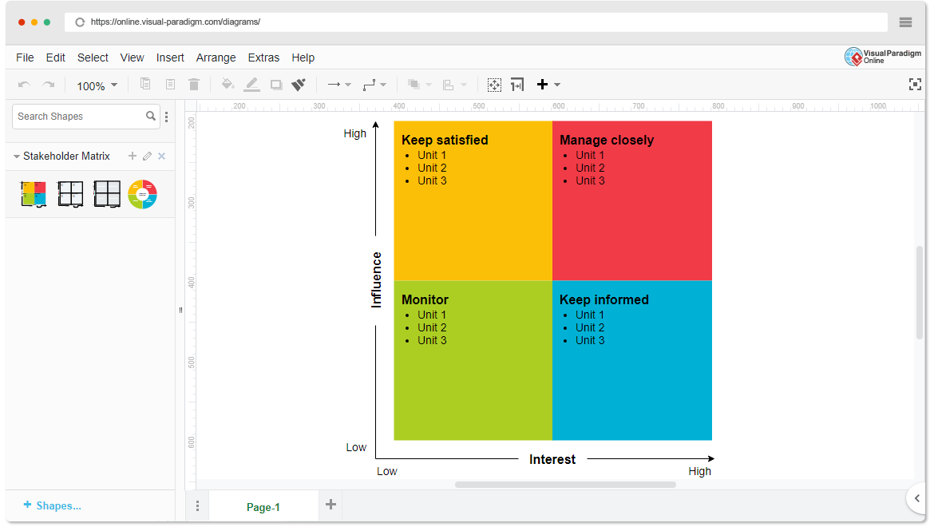

* High Power, High Interest: [Stakeholder Names]
* High Power, Low Interest: [Stakeholder Names]
* Low Power, High Interest: [Stakeholder Names]
* Low Power, Low Interest: [Stakeholder Names]

1. **Empathetic Interviews**

**Conduct Skilled interview with at least 30 citizens/Users by asking open ended questions (What, why/How etc) and list the insights as per the format below**

|  |  |  |
| --- | --- | --- |
| **I need to know**  **(thoughts, feelings, actions)** | **Questions I will ask**  **(open questions)** | **Insights I hope to gain** |
| Thoughts |  |  |
|  |  |  |
|  |  |  |
| Feelings |  |  |
|  |  |  |
|  |  |  |
| actions |  |  |
|  |  |  |
|  |  |  |

**SKILLED INTERVIEW REPORT**

**(Examples are given. Erase them and fill with your user information.)**

|  |  |  |
| --- | --- | --- |
| **User/Interviewee** | **Questions Asked** | **Insights gained (NOT THEIR ANSWERS)** |
| Abhishek Verma,  Student | Which party do you vote for? | Citizens are not very open about their political preferences |
| Srinivasan P., Parent | How do you feel about the plans for a new capital? | Some citizens are sad that the capital is being relocated from Hyderabad. |
|  |  |  |
|  |  |  |
|  |  |  |

**Key Insights Gained:**

* **Insight 1**
* **Insight 2**

**Empathy Map**

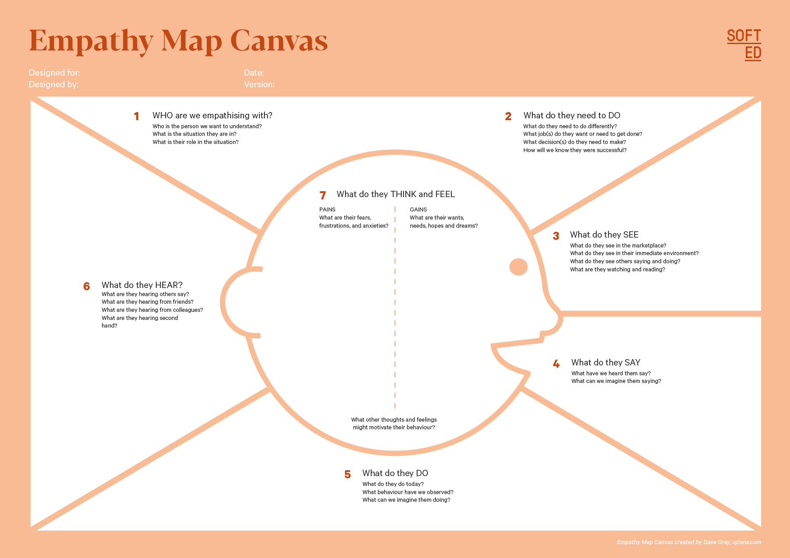

Your Answer:

Your Answer:

Who is your Customer Segment:

Idea/Innovation Title:

Designed By:

Date of Submission:

Your Answer:

Your Answer:

Your Answer:

Your Answer:

Your Answer:

Your Answer:

Your Answer:

1. **Empathy Map**
2. **Who is your Customer?**

**Description: This is where you specify the customer or user you are empathizing with. It could be a specific user persona or a general user segment.**

**Key points:**

* **Define the customer profile clearly (e.g., age, profession, interests).**
* **State their goals and needs related to the innovation or product.**
* **Context in which the user will interact with your solution.**

1. **Who are we empathizing with?**

**Description: This area helps you define who the user is, what their situation looks like, and what role they play. It emphasizes understanding the user’s perspective in depth.**

**Key points:**

* **Define the user's characteristics (e.g., personality, values, and responsibilities).**
* **State the user's goals and challenges in their environment.**
* **What is the user's broader situation (professionally or personally)?**

1. **What do they need to DO?**

**Description: This section identifies what actions or tasks the user needs to perform. It helps highlight the expectations and demands the user faces.**

**Key points:**

* **Clarify the tasks or actions the user needs to complete.**
* **What decisions do they need to make?**
* **How do they define success or failure in their tasks?**

1. **What do they SEE?**

**Description: This focuses on the visual stimuli or environment that the user interacts with. It's important to consider what users see in their immediate surroundings and in their larger world.**

**Key points:**

* **What do users see in their physical and digital environment?**
* **What trends or competitors do they notice?**
* **How do these visual elements influence their behavior?**

1. **What do they SAY?**

**Description: This section captures what the user might say in public, such as comments or feedback they give in conversations or on social media.**

**Key points:**

* **What might users express openly in conversation about their problems?**
* **How do they express their goals or frustrations?**
* **What are their words during customer interviews or feedback?**

1. **What do they DO?**

**Description: This section focuses on what the user does, the actual behaviors they exhibit, and actions they take in different situations.**

**Key points:**

* **What observable actions do users take?**
* **What habits or routines do they follow?**
* **What might users do to try and solve their problems?**

1. **What do they HEAR?**

**Description: This addresses what information the user receives from external sources, such as colleagues, media, or industry trends. It helps map the influences surrounding the user.**

**Key points:**

* **What are they hearing from peers, mentors, or the industry?**
* **What media or channels of information are they exposed to?**
* **Are there any strong influencers guiding their behavior?**

1. **What do they THINK and FEEL?**

**Description: This is one of the most insightful sections, addressing the internal emotions, concerns, and motivations of the user. It helps identify their deep-rooted feelings.**

**Key points:**

* **What are their fears, worries, and anxieties?**
* **What are their motivations and desires?**
* **How do their thoughts and feelings align with their actions?**

1. **Pains and Gains**

**Description: This section focuses on the user’s frustrations and their desired outcomes. It helps to frame the user’s challenges (pains) and the benefits they seek (gains).**

**Key points:**

* **What are the user’s main pain points?**
* **What would make their life easier or more fulfilling?**
* **What benefits do they hope to achieve from your product or solution?**

**8. Persona of Stakeholders**

**Stakeholder Name:**

**Demographics: Key characteristics of your target audience, such as age, gender, income, and location.**

**Goals: What the stakeholders or customers want to achieve in relation to the innovation.**

**Challenges: The obstacles or difficulties faced by stakeholders that the innovation aims to address.**

**Aspiration: The long-term desires or dreams of your target audience related to the innovation.**

**Needs: The essential requirements of your customers or stakeholders that must be met.**

**Pain Points: Specific problems or frustrations experienced by the target audience.**

**Storytelling: A narrative that highlights the journey of the stakeholder or customer, illustrating the problem and how the innovation can solve it.**

**Sample:**

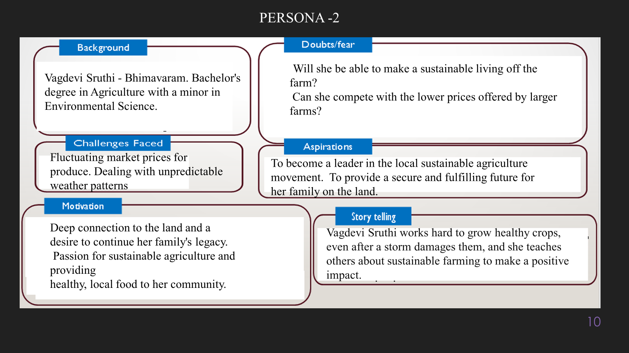

**10. Look for Common Themes, Behaviors, Needs, and Pain Points among the Users**

Analyse the data from your affinity diagram to uncover recurring patterns among your users, helping you better understand their expectations and challenges.

**Common Themes: Identify broad ideas or issues that repeatedly appear across different groups in your affinity diagram.**

**Common Behaviors: Observe how users consistently act or respond in relation to the problem or product throughout their journey.**

**Common Needs: Pinpoint essential requirements or desires that many users share, highlighting what they need for a better experience.**

**Common Pain Points: Look for frustrations or obstacles that frequently hinder the user experience, which your project can address.**

**12. Define Needs and Insights of Your Users**

**User Needs: Define the core requirements your users have in relation to the problem or product. These could be functional, emotional, or societal needs that your solution must address.**

**User Insights: Summarize the key understandings or observations you've uncovered about your users' behaviors, motivations, and pain points. These insights provide a deeper understanding of why users behave the way they do and what drives their decisions.**

**13. POV Statements**

**POV Statements:**

* [User] needs a way to [need] because [insight].

|  |  |  |  |
| --- | --- | --- | --- |
| PoV Statements  (At least ten) | Role-based or Situation-Based | Benefit, Way to Benefit,  Job TBD,  Need (more/less) | PoV Questions  (At least one per statement) |
| (Erase this example) When I drive to work, I want to avoid traffic jams so I don’t get in trouble with my boss for being late. | Situation | Way to Benefit | What can we design that will enable drivers to avoid traffic jams?  What can we design that will enable workers to avoid getting in trouble for being late to work? |
|  |  |  |  |
|  |  |  |  |
|  |  |  |  |
|  |  |  |  |

**14. Develop POV/How Might We (HMW) Questions to Transform Insights/Needs into Opportunities for Design**

Turn your user needs and insights into actionable opportunities by framing them as "How Might We" (HMW) questions. These questions will spark creative problem-solving and guide your innovation process.

1. **How Might We: Based on the needs and insights you've identified, create open-ended questions starting with "How might we...?" These questions should aim to solve user pain points, enhance the experience, or address specific needs.**

**Examples:**

* **User Need: "Users need a quicker way to access customer support."**
  + **HMW Question: "How might we create a more efficient and accessible customer support system?"**
* **Insight: "Users feel overwhelmed by too many options."**
  + **HMW Question: "How might we simplify decision-making for our users?"**

**Task:**

**Write 3-5 "How Might We" questions based on your analysis of user needs and insights. These questions should challenge you to think of innovative solutions that can address user problems in meaningful ways.**

**This task encourages participants to think creatively about solving user problems, transforming challenges into opportunities for innovation.**

|  |  |
| --- | --- |
| User Need/Insight | "How Might We" Question |
| [State the user need or insight clearly] | **How might we... [formulate an open-ended question to address the need or insight]?** |

**16. Crafting a Balanced and Actionable Design Challenge**

The Design Challenge Should Neither Be Too Narrow Nor Too Broad and It Should Be an Actionable Statement with a quantifiable goal. It should be a culmination of the POV questions developed.

**Design Challenge:** [Actionable Statement]

**17. Validating the Problem Statement with Stakeholders for Alignment**

Ensure your problem statement accurately represents the needs and concerns of your stakeholders and users. This involves gathering feedback from these groups to confirm that the problem is relevant and significant from their perspective. By validating early, you can refine the problem statement to better align with real-world challenges, ensuring your solution addresses the correct issues.

**Validation Plan:**

**Stakeholder/User Feedback (Min. 10 Stakeholders/Experts):**

|  |  |  |  |
| --- | --- | --- | --- |
| Stakeholder/User | Role | Feedback on Problem Statement | Suggestions for Improvement |
| [Name/Group] | **[Role/Title]** | **[Does the problem resonate with them? Why or why not?]** | **[Suggestions for refining the problem statement]** |
| [Name/Group] | **[Role/Title]** | **[Does the problem resonate with them? Why or why not?]** | **[Suggestions for refining the problem statement]** |

**18. Ideation**

**Ideation Process:**

|  |  |  |  |
| --- | --- | --- | --- |
| Idea Number | Proposed Solution | Key Features/Benefits | Challenges/Concerns |
| Idea 1 | **[Brief description of solution]** | **[What are the key benefits of this solution?]** | **[What challenges or concerns exist?]** |
| Idea 2 | **[Brief description of solution]** | **[What are the key benefits of this solution?]** | **[What challenges or concerns exist?]** |
| Idea 3 | **[Brief description of solution]** | **[What are the key benefits of this solution?]** | **[What challenges or concerns exist?]** |
| Idea 4 | **[Brief description of solution]** | **[What are the key benefits of this solution?]** | **[What challenges or concerns exist?]** |
| Idea 5 | **[Brief description of solution]** | **[What are the key benefits of this solution?]** | **[What challenges or concerns exist?]** |

**18. Idea Evaluation**

Evaluate the Idea based on 10/100/1000 grams

|  |  |  |  |  |
| --- | --- | --- | --- | --- |
| Idea | Impact (10/100/1000 grams) | Feasibility (10/100/1000 grams) | Alignment (10/100/1000 grams) | Total Weight |
| Idea 1 | **[Assign weight]** | **[Assign weight]** | **[Assign weight]** | **[Sum of weights]** |
| Idea 2 | **[Assign weight]** | **[Assign weight]** | **[Assign weight]** | **[Sum of weights]** |
| Idea 3 | **[Assign weight]** | **[Assign weight]** | **[Assign weight]** | **[Sum of weights]** |
| Idea 4 | **[Assign weight]** | **[Assign weight]** | **[Assign weight]** | **[Sum of weights]** |
| Idea 5 | **[Assign weight]** | **[Assign weight]** | **[Assign weight]** | **[Sum of weights]** |

**Example:**

|  |  |  |  |  |
| --- | --- | --- | --- | --- |
| Idea | Impact (10/100/1000 grams) | Feasibility (10/100/1000 grams) | Alignment (10/100/1000 grams) | Total Weight |
| Idea 1 | **1000** | **100** | **1000** | **2100** |
| Idea 2 | **100** | **1000** | **100** | **1200** |
| Idea 3 | **100** | **100** | **100** | **300** |

Further, use solution concept form to scrutinize the idea

**Solution Concept Form**

**1. Problem Statement:**

* **[State the validated problem your solution addresses.]**

**2. Target Audience:**

* **[Describe the main users or customers who will benefit from this solution.]**

**3. Solution Overview:**

* **[Provide a brief description of the solution concept.]**

**4. Key Features:**

| **Feature** | **Description** |
| --- | --- |
| **Feature 1** | **[Briefly describe the main feature of your solution]** |
| **Feature 2** | **[Briefly describe another key feature]** |
| **Feature 3** | **[Briefly describe a third key feature]** |

**5. Benefits:**

| **Benefit** | **Description** |
| --- | --- |
| **Benefit 1** | **[What value does this solution bring?]** |
| **Benefit 2** | **[How does this solution solve the problem?]** |
| **Benefit 3** | **[What makes this solution stand out?]** |

**6. Unique Value Proposition (UVP):**

* **[Summarize why this solution is unique and why it will appeal to your target audience.]**

**7. Key Metrics:**

| **Metric** | **Measurement** |
| --- | --- |
| **Metric 1** | **[What is the key metric to measure success?]** |
| **Metric 2** | **[What is another key metric for tracking progress?]** |

**8. Feasibility Assessment:**

* **[Provide a brief evaluation of how achievable or practical this solution is (consider resources, time, and technology).]**

**9. Next Steps:**

* **[Outline the next steps for further developing or prototyping this solution.]**